CURRICULUM VITAE

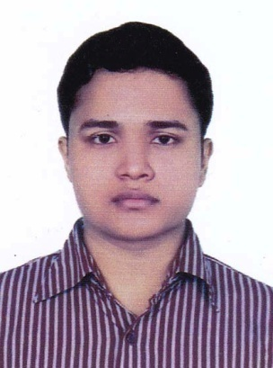

OF

RAHMAN ISHRAQUE KHAN

MOBILE: +8801955066087

Email: rahmanishraque1997@gmail.com

CAREER OBJECTIVES:

Willing to build up career in a challenging position and to prove myself as a quick learner and Highly energetic person to face any challenge in the Information power Technology sector where the contribution will be acknowledge, if would be given an opportunity.

EDUCATIONAL QUALIFICATION:

* *DIPLOMA-IN-ENGINEERING*:
  + Name of the Institution : Chittagong Polytechnic Institute, Chittagong
  + Technology : Power Technology
  + Roll No : 872982
  + Passing year : 2018
  + Obtained C.G.P.A : 2.89
  + Board : Bangladesh Technical Education Board, Dhaka
* *SECONDARY SCHOOL CERTIFICATE:*
  + Name of the Institution : Chittagong Colligate School & College.
  + Group : Science
  + Roll No : 103204
  + Passing year : 2014
  + Obtained G.P.A : 4.56 (out of 5.00)
  + Board : Chittagong

ACHIEVEMENTS:

* + - Strong communication and interpersonal skills
    - Good analytical and problem solving skills.

COMPUTER LIABILITY:

* Microsoft Office, Power Point, Internet Browsing & Emailing etc

INDUSTRICAL TRAINING & PRACTICE:

* + 4-montths industrial training in “Bangladesh Railway Parhartali Workshop Chittagong”

LANGUAGE SKILLS:

* + Bangla : Good
  + English : Good

RELEVANT SKILLS:

* + - Capable of working in a team as well as independently.
    - Comfortable with working long hours in the site as well as an organization.
    - Fluent in speaking writing & listening in both English and Bengali.

PERSONAL INFORMATION:

* Name : Rahman Ishraque Khan
* Father Name : Abu Sayed Mohammad Ishaque
* Mother Name : Rubina Afroz
* Nationality : Bangladeshi
* Religion : Islam
* Sex : Male
* Marital Status : Unmarried
* Date of Birth : 19/06/1999
* Height : 5′-6″
* Weight : 64kg
* Blood Group : A+ (positive)
* Birth Place : Chittagong

PERMANENT ADDRESS:

* + Vill : Chapiratala
  + Post Office : Shangishor(3583)
  + Police Station : Chauddagram
  + District : Kumilla

PRESENT ADDRESS:

* + Village : Achiya Chad Khan Bhaban,1 no road, 8no Moshjid lane, Ramna R/A, North Agrabad, Chittagong.
* Post Office : Rampur(4224)
* Police Station : Halishor
* District : Chittagong

1. Mohammad Maine Uddin 2. Md. Ataur Rahman

Junior Instructor Junior Instructor

Power Technology Power Technology

Chittagong Polytechnic Institute Chittagong Polytechnic Institute

Cell: 01914-699530 Cell: 01839437237

Reference by:

DECLARATION:

“I do hereby declare and certify that all the information stated above in these Curriculum vitae are true and complete to the best of my knowledge and belief”.

Date:……………………………. (Rahman Ishraque Khan)

